**MUHAMMAD SHAF HAMEED**

**ASSIGNMENT NO 7**

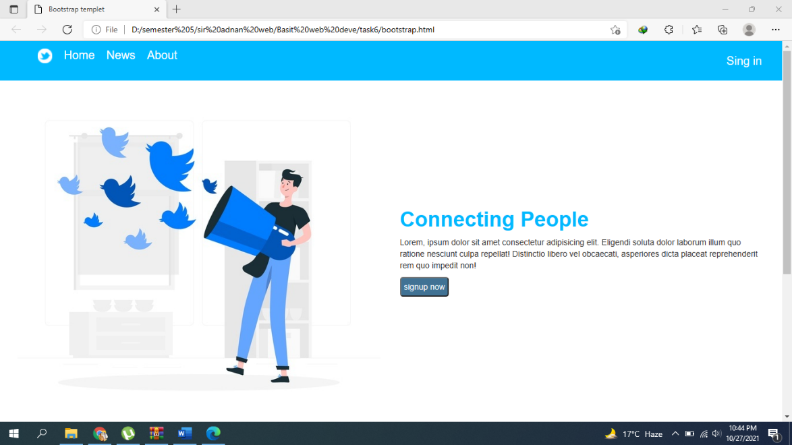**SAMPLE 1:**

**SAMPLE 2**

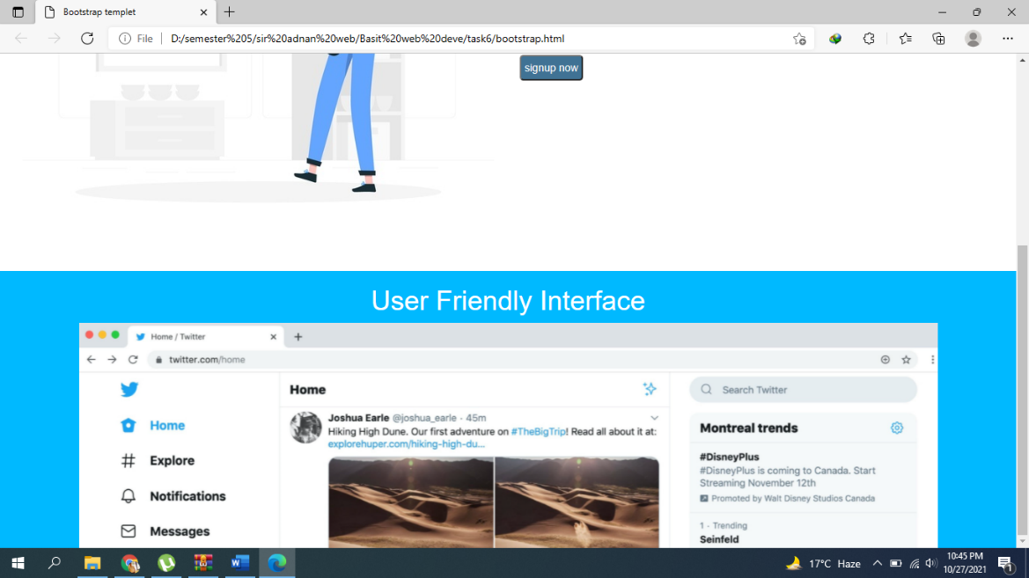

**HTML CODE:**

<!DOCTYPE html>

<html>

<head>

    <meta charset="utf-8">

    <title>Bootstrap templet</title>

    <link rel="stylesheet" type="text/css" href="style.css">

    <link rel="stylesheet" href="https://maxcdn.bootstrapcdn.com/bootstrap/3.4.1/css/bootstrap.min.css">

    <!-- jQuery library -->

    <script src="https://ajax.googleapis.com/ajax/libs/jquery/3.5.1/jquery.min.js"></script>

    <!-- Latest compiled JavaScript -->

    <script src="https://maxcdn.bootstrapcdn.com/bootstrap/3.4.1/js/bootstrap.min.js"></script>

</head>

<body>

    <DIV class="container-fluid ABC">

        <ul>

            <li><img src="logo.png"></li>

            <li>Home</li>

            <li>News</li>

            <li>About</li>

            <li class="move">Sign in</li>

        </ul>

    </DIV>

    <div class="container-fluid">

        <div class="col-md-6">

            <img src="./twitterconcept.jpeg" alt="">

        </div>

        <div class="col-md-6 abc1">

            <h1>Connecting People</h1>

            <p>Lorem, ipsum dolor sit amet consectetur adipisicing elit.

                Eligendi soluta dolor laborum illum quo ratione nesciunt culpa repellat! Distinctio libero vel

                obcaecati,

                asperiores dicta placeat reprehenderit rem quo impedit non!</p>

            <button>signup now</button>

        </div>

    </div>

    <div class="container-fluid abc2">

        <h1> User Friendly Interface</h1>

        <div class="container">

            <img src="./slider3.jpg" alt="">

        </div>

    </div>

</body>

</html>

**CSS CODE:**

.ABC{

    background-color: #00b9ff;

}

.ABC img{

     height: 25px;

     width: 25px;

     background-color: #00b9ff;

}

li{

    float: left;

    margin: 10PX 10PX;

    list-style-type:none;

    font-size: 20px;

    color: white;

}

.move{

    float: right;

    margin: 20px;

}

 .ABC ul li:hover{

    background-color: blue;

}

.abc1{

    margin-top: 200px;

}

.abc1 h1{

    font-weight: bold;

    color: #00b9ff;

}

.abc1 button{

    background-color: #407294;

    color: white;

    border-radius: 5px;

    padding: 5px;

}

.abc2{

    background-color: #00b9ff;

}

.abc2 h1{

    text-align: center;

    color: white;

}

.container img{

    width: 100%;

}